CHAINS AND AGENTS
After learning this topic, we will be able to describe LangChain’s chains for response generation, describe memory storage in LangChain and define agents in LangChain.

CHAINS
​In LangChain, chains are a sequence of calls. ​A sequential chain consists of ​basic steps where each step takes ​one input to generate one output ​to create one seamless flow of information. ​The output from Step 1 becomes the input for Step 2.
Example: Let's look at the creation of ​a sequential chain of three individual chains. ​The aim of this chain is to identify the recipe and ​the estimated cooking time for ​the famous dish available in the inserted location. ​The users leverage Chain 1 for selecting ​the geographic region to get ​the famous dish in that location, ​Chain 2 for providing the recipe, ​and Chain 3 for estimating the cooking time. ​
https://docs.google.com/document/d/1ZEZ1ZkGcJs2-zrLNNmBg1ybrgZboyJy_b7MCe1j2J0Q/edit?tab=t.0 (example for sequential chain)

MEMORY
In LangChain, memory storage is important for reading and writing historical data. ​Each chain relies on specific input, ​such as user and memory. ​Chain reads from memory to ​enhance user inputs before executing ​its core logic and writes ​the current runs inputs and ​outputs back to the memory after execution. ​This ensures continuity ​and context preservation across interactions.
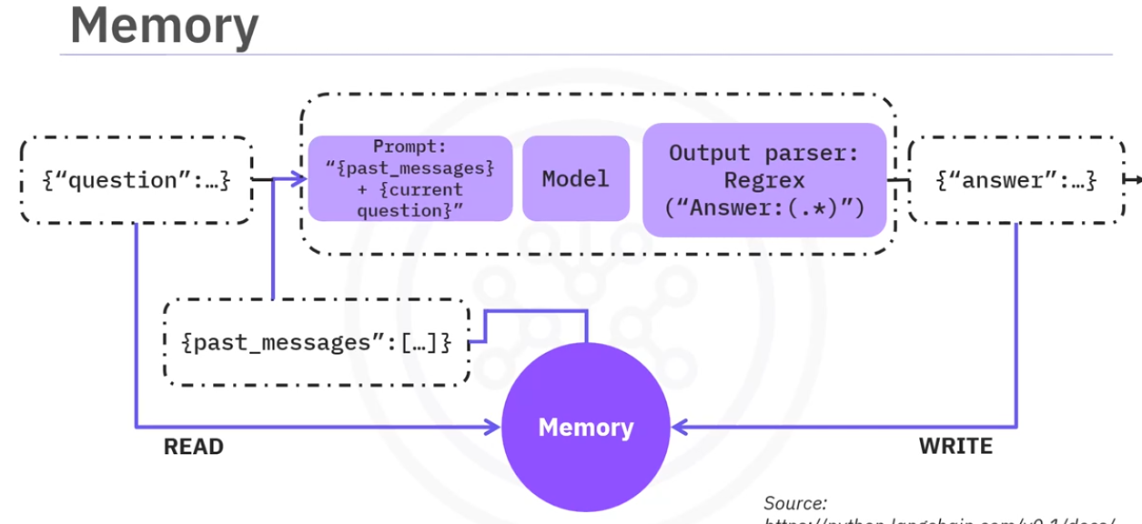The chat message history class in LangChain is ​designed to manage and store ​conversation histories effectively, ​including human messages and AI messages. ​This allows adding messages from ​the AI and users to the history.
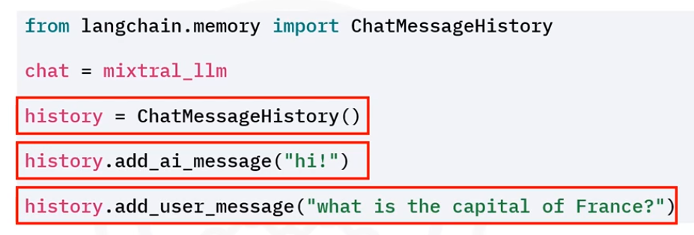 https://docs.google.com/document/d/1ZEZ1ZkGcJs2-zrLNNmBg1ybrgZboyJy_b7MCe1j2J0Q/edit?tab=t.6p4wcul8zi18

AGENTS
Agents in LangChain are dynamic systems where ​a language model determines and ​sequences actions such as pre-defined chains. ​The model generates text outputs to guide actions, ​but does not execute them directly. ​However, agents integrate with ​tools such as search engines, ​databases, and websites to fulfil user requests. ​For example, if a user asks for the population of Italy, ​the agent uses the language model to find options, ​query a database for details, ​and return a curated list.
​This shows the agent's ability to ​autonomously leverage LLM reasoning with external tools.
Let’s take a look at an example. We will be creating a Pandas DataFrame agent using LangChain. This agent allows users to query ​and visualize data with natural language.
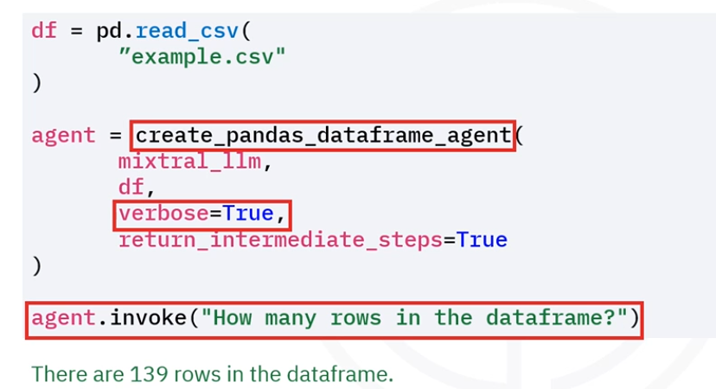In order to understand click on this link: https://docs.google.com/document/d/1ZEZ1ZkGcJs2-zrLNNmBg1ybrgZboyJy_b7MCe1j2J0Q/edit?tab=t.u4fxvd6j78fm

